**Results of programmes:-**

**Question1:-**

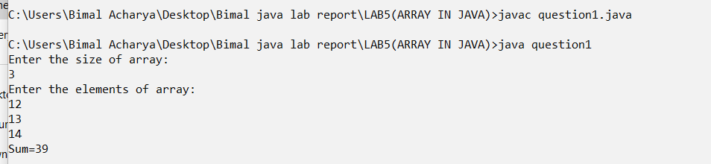

**Question2:-**

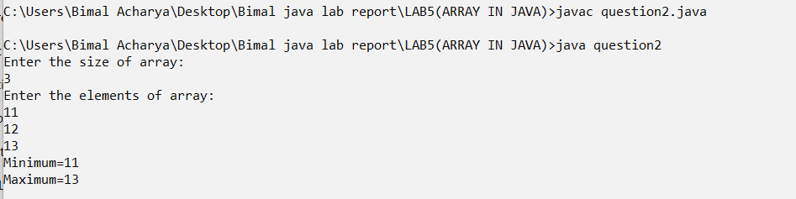

**Question3:-**

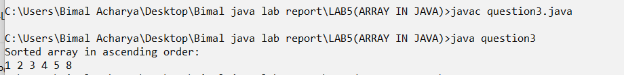

**Question4:-**

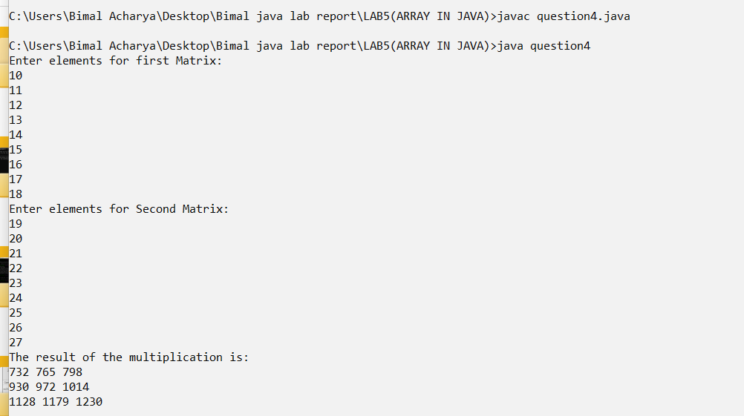

**Question5:-**

